PRESS RELEASE

FOR IMMEDIATE RELEASE

ULM - Philippines Relation Strengthens ASEAN Community’s Bond

Banjarmasin, Kominfo Newsroom – Lambung Mangkurat University (ULM) in South Kalimantan and the Philippines is intensively collaborating to educate children from Davao, Mindanao Island, Philippines, in a scholarship program scheme for international students to help strengthen relations between ASEAN communities.

"Especially for the 2022-2023 academic year, there were five children from graduates of the Davao Indonesia School (SID), Philippines, studying at ULM," said ULM Rector Prof. Ahmad Alim Bachri in Banjarmasin, Tuesday (18/4/2023).

He hoped that in 2023 more international students, including Davao children, could study at ULM as cooperation is established with various Southeast Asian or ASEAN countries.

"Our target this year is to have a hundred foreign students studying at ULM in regular lectures and student exchange programs," he said.

Alim admitted that the presence of international students had positively impacted the academic atmosphere at ULM, which continues to strive to be at the highest level nationally or the best state university on the island of Kalimantan.

Moreover, ULM has been determined by the Education, Culture, Research, and Technology Ministry to enter the independent cluster. In that cluster, ULM is included in the best forty top Indonesian universities in the 2023 higher education cluster.

Specifically, the cooperation program agreed upon by ULM and the Indonesian Davao School (SID), Philippines, has been going on since 2018, with 22 students.

In addition to providing college scholarships for graduates of the Indonesian Davao School, ULM held a Student Teachers Program where ULM students practiced teaching at the Indonesian Consulate General in Davao City, the Philippines.

"ULM is proud to be able to provide higher education for Davao children so that they become a quality generation in other countries," explained Alim.

Generally, most SID children have not determined their citizenship status before they turn eighteen.

However, most children born and live around General Santos City, Balut Island, and Sarangani Island prefer to become Indonesian citizens because their parents come from the Sangihe Islands, North Sulawesi Province, Indonesia.

The existence of student exchanges with fellow countries in Southeast Asia is expected to support ASEAN inter-community relations amid the 2023 ASEAN Indonesia Chairmanship.

The chairmanship of Indonesia adopts the theme "ASEAN Matters: Epicentrum of growth, " meaning ASEAN is important and relevant as a center of growth. (Firman/Elvira/TR)

***

For further information, please contact:
Director General of Public Information and Communications of the Ministry of Communications and Informatics – Usman Kansong (0816785320).

Get more information at https://infopublik.id

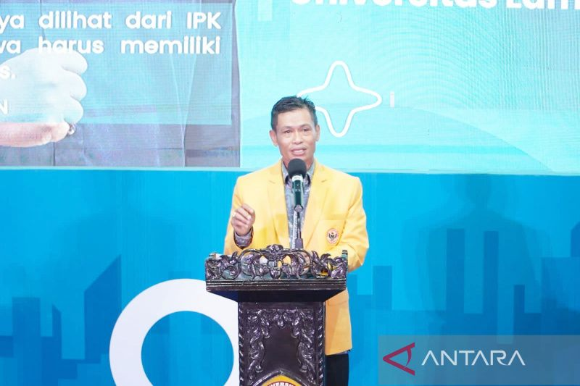

ULM Rector Prof. Ahmad Alim Bachri. (ANTARA/Firman)

